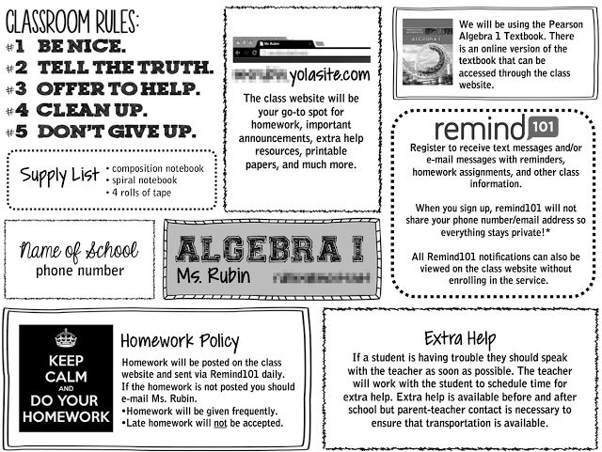C:\Users\owner\AppData\Local\Microsoft\Windows\Temporary Internet Files\Content.IE5\7QGVO63S\MC900326478[1].wmfC:\Users\owner\AppData\Local\Microsoft\Windows\Temporary Internet Files\Content.IE5\7QGVO63S\MC900048276[1].wmfC:\Users\owner\AppData\Local\Microsoft\Windows\Temporary Internet Files\Content.IE5\SBP7811U\MC900434665[1].wmf

**Rules**

***BE PROMPT!***  *Be in your seat BEFORE the bell rings. You will be marked tardy if you are not in your seat at that time.*

***BE PREPARED!*** *Bring all required materials to class, every day. You will be marked tardy if you are not prepared for class. Chronic unpreparedness is unacceptable!!*

***BE PRODUCTIVE!*** *Listen to instructions the FIRST time they are given and stay on task (the more you get done during class the less you have to do at home)!*

***BE POLITE!*** *Respect each other and the equipment in the science room. Do not interfere with the learning of any student at any given time.*

***Late Work: Life Happens! If you anticipate an assignment being late please let me know so we can work out an acceptable arrangement. Failure to do so will result in a 10% grade reduction per day late. No work will be accepted one week after the posted deadline, unless prior arrangements have been made. Work not turned in will receive a zero.***

***\*NOTE: I can’t grade what I can’t read! Illegible assignments and/or assignments containing numerous grammatical errors that restrict the flow of communication will be returned ungraded and must be redone. The assignment will be subject to a late penalty.***

**Register to receive class reminders:**

**Text: @huskey10 To: 81010**

***Units:***

**Mrs. Robbins arobbins@hansen.k12.id.us**

**Room 1 (208) 423-5593 ext.2218**

*BIOLOGY: The study of life, living things, and the interactions between organisms*

*Class Website: http://mrsrobbinsclassroompage.weebly.com/*